**Technical Design Document**

Project name: **Airline Reservation System**

Developed by: Hitesh Varma

**Introduction:**

Airline Reservation System is created to meet the needs of online flight reservation system, with functionalities:

* Booking Flight
* Check Bookings
* Cancel Bookings

**Functional Requirements:**

**Login/Signup:**

A user will be required to log in into the application in order to book tickets. If he/she has no account, they have to register by providing their names, their contact number and other few details.

**Search Flight:**

On providing the required boarding and arrival details user can fetch the details of the flight. And the next step would be reservation on providing some additional details.

**Flight Reservation:**

A user will be able to create a new Reservation by choosing a flight and providing the details of passenger. After filling all the conformations user is all set for payment.

**View Bookings:**

View bookings option allows users to see all the reservations made and now able to cancel the reservation by choice.

**Cancel Booking:**

After clicking on “Cancel Booking” button, a user will receive a confirmation about cancellation of the selected reservation.

**Overall Architecture Diagram:**

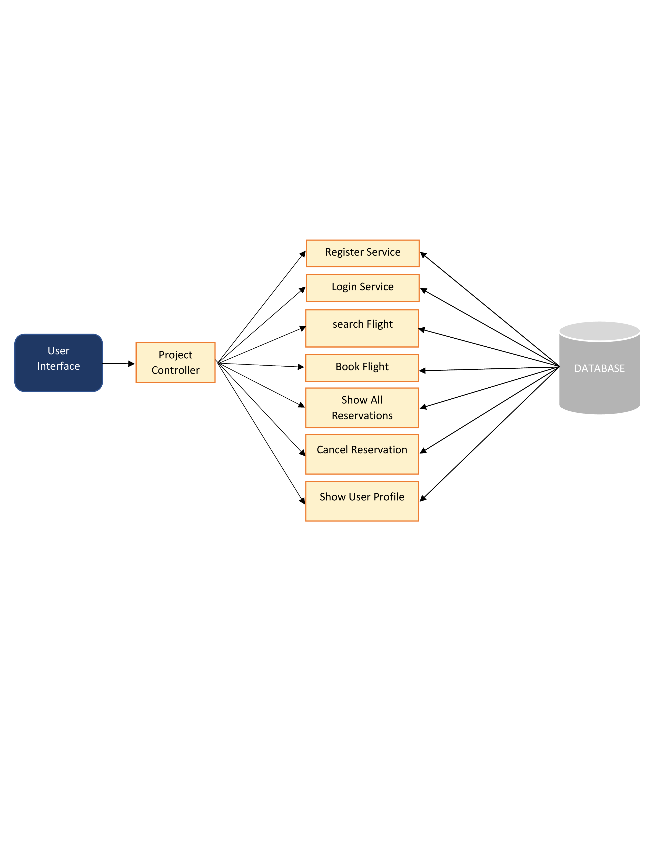

**Overall Entity Relationship Diagram:**

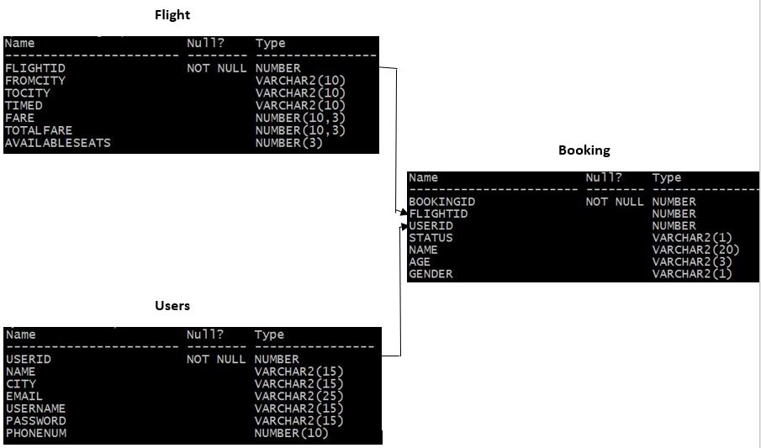

**Class Diagram**

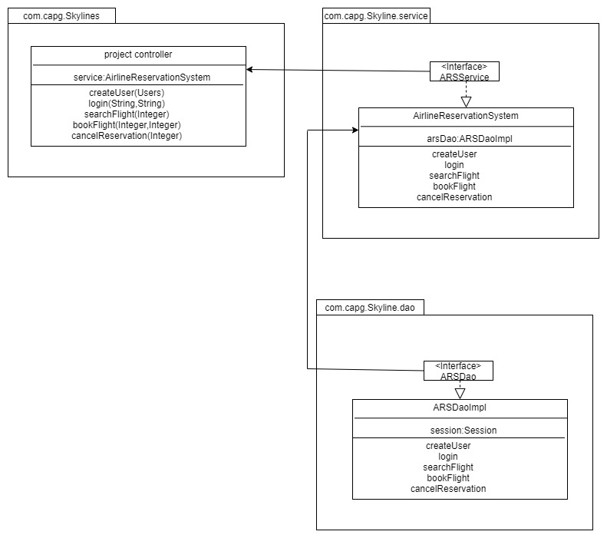

**Activity Diagrams**

**Login:**

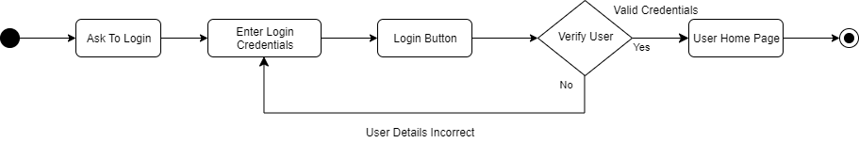

**Registration:**

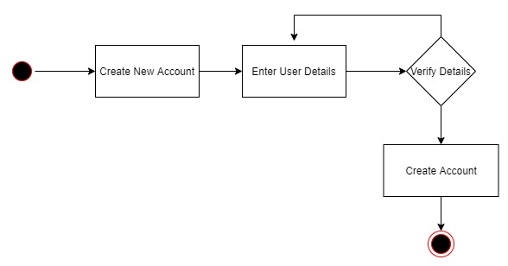

**Search and Book:**

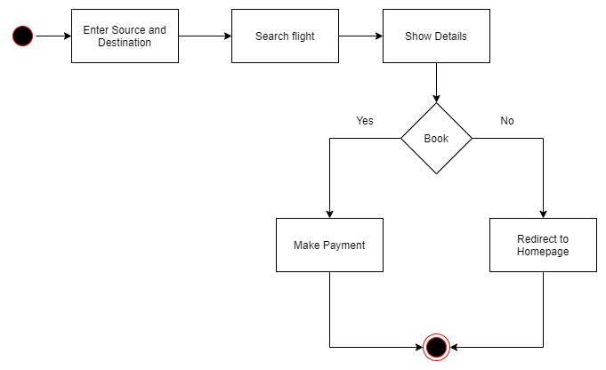

**Cancel Reservation:**

